OWASP Dependency-Track

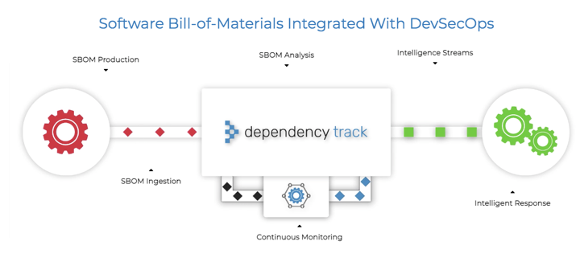

<https://dependencytrack.org/>

https://owasp.org/www-project-dependency-track/

* Tracks application, library, framework, operating system, and hardware components
* Tracks component usage across all version of every application in an organizations portfolio
* Identifies multiple forms of risk including
* Components with known vulnerabilities
* Out-of-date components
* Modified components
* License risk